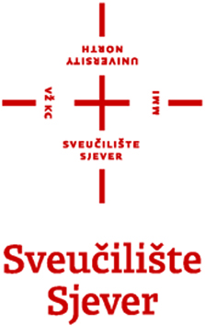
ACCEPTANCE CONFIRMATION
ERASMUS+ STUDENT MOBILITY FOR TRAINEESHIP, 2014/15

Name of organisation/company providing the training:
Address:
Person in charge:
Country where the company is based:
Country where the training will take place:
Size of the enterprise, according to approx. number of staff: | 1-20 staff  21-50  51-250 | 251-500  501-2000 | 2001-5000  >5000 staff
Type of Traineeship Sector (NACE Sector Codes)
Contact person / Student's mentor:
E-mail:
Phone:
Fax:

The organisation/company _____________________________ (name of the organisation/company) confirms to accept ___________________________ (name of the student), a student at the University of Zagreb, in the period from __/__/_____ (day,month,year) until __/__/_____ (day,month,year), for the purpose of student traineeship (placement /internship) within the Erasmus+ mobility programme in the academic year 2014/2015.
The organisation/company binds itself to complete the student traineeship programme according to the working plan which will be defined in the document "Learning Agreement for Traineeships" and agreed upon by all three parties: the student, the student's home faculty and the organisation/company providing the training.
The student will get payment from organisation/company: no / yes ( approx. ____€ / month).
The official working language of the traineeship will be ___________________, and the student is required the minimum knowledge level of _________ according to Common European Framework of Reference for Languages (CEFR).

Date and place: _________________ Signature of the person in charge and stamp:

The list of top-level NACE sector codes is available at: http://ec.europa.eu/eurostat/ramon/nomenclatures/index.cfm?TargetUrl=LST_NOM_DTL&StrNom=NACE_REV2&StrLanguageCode=EN.
Please provide official stamp of the company/organisation. Only in case that the stamp is not being in use by the company, please provide a separate official statement explaining this issue.

