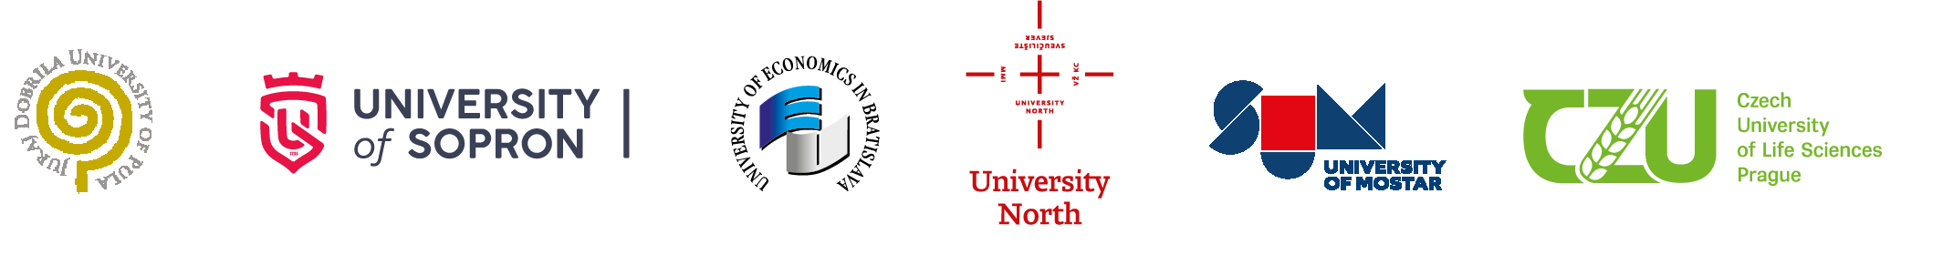

The University of Applied Sciences Burgenland is offering in Eisenstadt
THE TWO INTERNATIONAL JOINT CROSS-BORDER INTERDISCIPLINARY DOCTORAL PhD-PROGRAMMES, notified, accredited and registered by the AQ Austria, Vienna.

In 2014, the Joint doctoral programme "International Joint Cross-border PhD Programme in International Economic Relations and Management" was launched, where the participating partner institutions /universities are:
- JURAJ DOBRILA UNIVERSITY OF PULA, CROATIA
- UNIVERSITY OF ECONOMICS IN BRATISLAVA, FACULTY OF INTERNATIONAL RELATIONS, BRATISLAVA, SLOVAKIA
- UNIVERSITY OF SOPRON, ALEXANDRE LAMFALUSSY FACULTY OF ECONOMICS, SOPRON, HUNGARY
- UNIVERSITY NORTH, CROATIA
- UNIVERSITY OF MOSTAR, FACULTY OF ECONOMICS, MOSTAR, BOSNIA and HERCEGOVINA
- CZECH UNIVERSITY OF LIFE SCIENCES PRAGUE, FACULTY OF ECONOMICS AND MANAGEMENT, PRAGUE, CZECH REPUBLIC.
The registration and notification of this doctoral joint study programme by the AQ Austria, Vienna is valid until September 2027.

In 2017, the joint doctoral programme “ International Cooperative Cross-Border Interdisciplinary Doctoral Programme in Educational & Communication Sciences” with

- UNIVERSITY OF LJUBLJANA, FACULTY OF EDUCATION, LJUBLJANA, SLOVENIA
- INTERNATIONAL BURCH UNIVERSITY, FACULTY OF EDUCATION AND HUMANITIES, SARAJEVO, BOSNIA and HERCEGOVINA
- UNIVERSITY NORTH, CROATIA
- UNIVERSITY OF MOSTAR, FACULTY OF HUMANITIES AND SOCIAL SCIENCES, MOSTAR, BOSNIA and HERCEGOVINA

Both PhD doctoral programmes , the International Joint Cross-Border PhD Programme in International Relations and Management and International Co-operative Cross-Border interdisciplinary doctoral programme in Educational& Communication Sciences are open to applicants who
- hold a Diploma or Master’s degree (5 years) or equivalent degree issued by an officially accredited university or institution of higher education
- submit complete application documents including a statement of personal motivation and a description of the intended research orientation;
- have at least two years of qualified professional experience
- master English on at least C1-level
- and successfully pass the admission process.

Highlights
- part-time studies to be completed within a minimum of 3years (6 semesters, 180 ECTS); to complete the doctoral dissertation a student may take up to six years
- language of tuition: English
- renowned and distinguished academics, professors and professionals of highly acclaimed universities
- individual and group tutorials, face2face sessions

Application process
For each academic year, the application process is organized along key dates. The deadline for submission of application documents is JUNE 30th, the personal interviews is are scheduled for October and the programme is due to start in November of each academic year.

If we raised your attention, please see the links
PhD Programme in International Economic Relations and Management - FH Burgenland (fh-burgenland.at)
Doctoral Programme in Educational & Communication Sciences - FH Burgenland (fh-burgenland.at)

For all further questions and details, feel free to contact the Director of the Centre for Doctoral Programmes at the University of Applied Sciences in Eisenstadt, Austria:
E-Mail: irena.zavrl@fh-burgenland.at
M: +43 664 8832 8351

