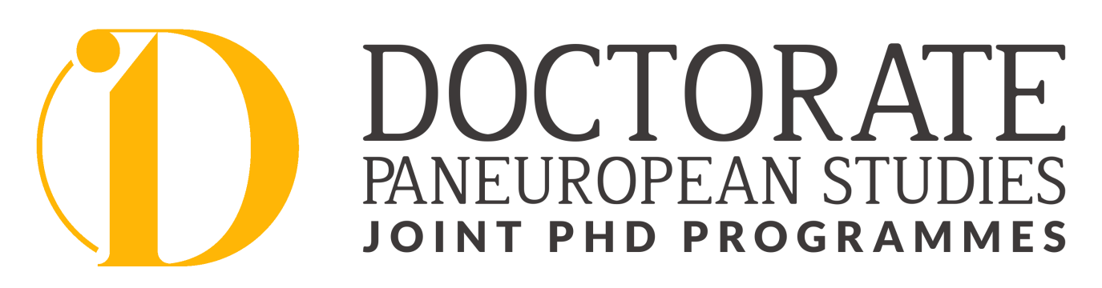
SCHEDULE 2025/26 EDU&COMM
International Cooperative Cross-Border Interdisciplinary Doctoral Programme in Educational & Communication Sciences
WS 2025/26 | Topic/Teaching Modules | Professor(s) | Venue | ECTS
October 09./10. 2025 | Admission Personal Interviews  Defences of RP, First Monitorings, Second Monitorings |  | Eisenstadt, Campus 2
October 11,2025, at 11.00 am | GRADUATION CEREMONY |  | Esterhazy Castle, Eisenstadt
November 21, 2025  11.00am -5.30 pm  5.30-open end | 10:00-11.00 Welcome &  Introduction to the Doctoral Study Programme  Teaching Module 1: Theoretical concepts in the Field of Education (I.) (THCE)  Get-together with Alumni | Prof. Dr. Sc. Janez Krek  Faculty of Education, University of Ljubljana, Slovenia | Eisenstadt, Campus 2 | 5 ECTS
November 22, 2025  09.30-5.30 pm | Teaching Module 2: Doctoral Seminar 1 (I.) (DSI) | Prof. D.Sc. Janez Vogrinc  Faculty of Education, University of Ljubljana, Slovenia | Eisenstadt, Campus 2 | 3 ECTS
December 5, 2025  10.00am- 5.30 pm | Teaching Module 3: Theoretical concepts in the Field of Education (II.) (THCE) | Prof. Dr. Sc. Pavel Zgaga  Faculty of Education, University of Ljubljana, Slovenia | Eisenstadt, Campus 2 | -
December 6, 2025  09.30-5.30pm | Teaching Module 4: Doctoral Seminar 1 (II.) (DSI) | Prof. Dr. Sc. Janez Vogrinc  Faculty of Education, University of Ljubljana, Slovenia | Eisenstadt, Campus 2 | -
January 16, 2026,  10.00 am-5.30 pm | Teaching Module 5:  Educational & Communication Research (EDUR)  Research in Education and Communication | Prof. Dr. Sc. Senad Bećirović | Eisenstadt, Campus 2 | 5 ECTS
January 17, 2026,  09.30am -5.30pm | Teaching Module 6:  Educational & Communication Research I (EDUR) | Prof. Dr. Sc. Senad Bećirović | Eisenstadt, Campus 2 | -
20./21. February 2026,  10.00am-5.00pm | Teaching Modules 7  Contemporary Trends in Research in the Field of Educational Sciences (I.)  or  Contemporary Trends in Research in the Field of Communication Sciences (I.) (CTR) | Prof. Dr. Sc. Janez Krek  Faculty of Education, University of Ljubljana, Slovenia  Prof. Dr. Sc. Davorka Topić Stipić  University of Mostar, BiH | Eisenstadt, Campus 2 | 5 ECTS
Individual scientific work | Module 8:  Publication credits  Preparation for International Scientific Conference for early-stage researchers and doctoral candidates | Review of abstract by supervisor(s) |  | 5 ECTS
 | Thesis work/Research credits |  |  | 7 ECTS
 |  |  |  | 30 ECTS

SoSe 2026 | Topic/Teaching Module | Professor | Venue | Place
March 20, 2026,  10.00am- 5.30pm | Teaching Module 9:  Doctoral Seminar 2 (I.) (DSI) | Prof. Dr. Sc. Janez Vogrinc  Faculty of Education, University Ljubljana, Slovenia | Eisenstadt, Campus 2 | 2 ECTS
March 21, 2026, 09.30-5.30 pm | Teaching Module 10:  Writing Scientific Articles and Presenting Research Results (WSA) | Prof. Dr. Sc. Janez Vogrinc  Prof. Dr. Sc. Iztok Devetak, PhD  Faculty of Education, University of Ljubljana, Slovenia | Eisenstadt, Campus 2 | 5 ECTS
April 17, 2025. 10.00 am -5.30 pm  April 18 , 2026, 09.30-5.30pm | Teaching Module 11:  Theories of Communication and Culture (TCC) | Assoc.-Prof. Dr. Sc. Tvrtko Jolić  University North Varaždin, Croatia | Eisenstadt, Campus 2 | 5 ECTS
May 28, 2025, 2.00-9.00pm | Teaching Module 12:  Doctoral Seminar 2 (II) (DSI) | Prof. Dr. Sc. Janez Vogrinc  Faculty of Education, University of Ljubljana, Slovenia | Eisenstadt, Campus 2 | -
12.-13. June 2026, 09.30-4.30pm | MODULE 13:  International Scientific Conference for early-stage researchers and doctoral candidates | representatives and professors from partner universities | Eisenstadt, AT
19 June 2026, 10.00 am -5.30 pm  20 June 2026, 09.30-5.30pm | Teaching Module 14:  Advanced Research Approaches in the Field of Education (ARA) | Prof. Dr. Sc. Janez Vogrinc  Faculty of Education, University of Ljubljana, Slovenia | Eisenstadt, Campus 2 | 5 ECTS
August 21, 2026 10.00 am -5.30 pm  August 22, 2026, 09.30 am-5.30pm | Teaching Module 15:  Pedagogy of Higher Education (PHE) | Prof. Dr. Sc. Senad Bećirović | Eisenstadt, Campus 2 | 5 ECTS
 | Module 16: Thesis work/Research credits |  |  | 3 ECTS
 |  | In TOTAL |  | 30 ECTS
Individual scientific work | Module 17: Publication credits |  |  | 5 ECTS
 |  |  |  | 30 ECTS

IMPORTANT DATES AND DEADLINES:
October 8-10, 2025.Admission Personal Interviews Defences of RP, First Monitorings, Second Monitorings: MOST PROBABLY by the end of October…
March 19-21, 2026: Defences of RP/First Monitorings/Second Monitorings/Final Defences
For defences in March: applications/registrations should be made by January 30, 2026, all other necessary documents should be handed in until February 28, 2026
October 8/9. 2026: Admission Interviews for the new doctoral candidates; Defences of RP/First Monitorings/Second Monitorings/Final Defences
For defences in October: applications/registrations should be made by August 31, 2026, all other necessary documents should be handed in until September 15, ,2026
October 10, 2026. Graduation Ceremony

