PAPER TITLE, maximum 2 rows, centred, uppercase

Name Surname; Name Surname; Name Surname
(One paper can have maximum 3 authors, one author can have maximum two papers submitted)

Abstract

The abstract represents a brief informative overview of the paper content, which should enable the reader to quickly and accurately comprehend its relevance. The authors should explain the objectives of the research or state the reason(s) for writing the paper. In addition, it is necessary to describe the methods used in the research and to briefly describe the results. The abstract should contain up to 150 words.

Keywords: up to 6 keywords, separated by commas

Introduction

This document represents a form for the formatting papers, so that they are ready for printing. The paper cannot be shorter than 6 pages (up to 8 pages), including abstract, charts, tables, images, schemes, attachments and literature. Introduction, subtitles, conclusions and literature in the paper are centred, without numbering, written in lower case letters with initial capitalization.

The page format is A4, 21 x 29,7 cm (Page Setup, Paper Size). Use 2.5 cm for all margins. Spacing between rows within a single paragraph is one (Single). To format the text, use the Times New Roman font, 12 pt. Papers should be submitted in English, Russian or languages of former Yugoslavian republics.

Elaboration/subtitle

The elaboration should be transparent and logically structured with an arbitrary number of subtitles.

Charts, tables, images, schemes and attachments are in black and white or colour technology; they must contain the title and source, marked with numbers and centred.

The size of the charts, images, charts and attachments should be customized to fit the page’s format and margins. The same applies to the size of the fonts in the table, so that they can clearly and completely appear on one page. Breaks are not allowed.

Table 1: Title, as well as the table, should be centred
First | Second | Third | Forth | Fifth
Text | Text | Text | Text | Text
Source: Source with the reference

Image 1: Title, centred
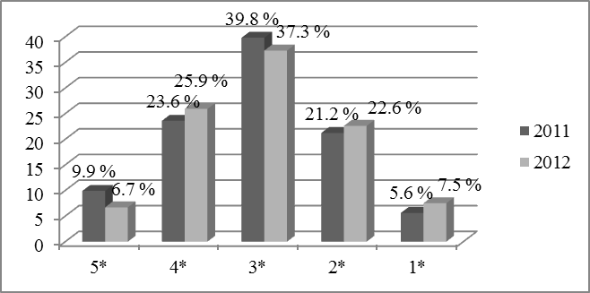
Source: Source with the reference

Formulas should be centred with numbering, as in the following example. It is recommended Microsoft Word (MathType) be formatted.

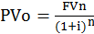 (1)

Enumeration...
- First
- Second
- Third

Numbering...
- First
- Second
- Third

Subtitle

Тext...

Subtitle

Тext...

Conclusion

Тext...

References

1. ...
References with numbering are listed in alphabetical order according to the author’s surname or institution as author.

The reference should contain the following elements in this ordering sequence:
- Surname and name of author/co-author or institution as author
- Edition year, in parentheses ():
- Title of the paper (Italic),
- Name of the publication/conference,
- Name and place of publisher/place and date of the conference
- Volume and number of publication,
- Pages from-to.

Example:
Book
1. Brzaković, T. (2003). Savremene poslovne finansije. Principi i primene, Fakultet za primenjeni menadžment, ekonomiju i finansije, Beograd.

Paper in journal
1. Vukajlović, Đ. (2015). Povećanje konkurentnosti privrede kroz razvoj zelene ekonomije. Ecologica, No. 78, 165-170.

Paper in conference proceedings
1. Radanov, P., Jovanović, V. (2017). Inovaciona ulaganja u automobilsku industriju. Međunarodni naučni skup „Inovacijama do održivog razvoja“, Beograd, 2015-223.

Reference in the form of an internet document (pdf, word, powerpoint, excel, etc.) is also listed in the alphabetical order according to the surname of the author or institution as an author (if there is no known author and institution as an author, it is listed according to the title of the document). It should contain the following elements, according this order:
- Surname and name of authors/co-author or institution as an author,
- Title of the document (Italic),
- Internet address (link),
- Date when the site is visited, in parentheses ().

Example:
1. Kraizer, S., Safe child, http://www.safechild.org/, (29 October 2012).

In the case of Internet references in the form of certain information/data from a site, where the author (the institution as the author and the title of the document) is not known, then such reference is also listed in the alphabetical order according to the title of the text on the site. It should contain the following elements according to this order:
- Title on the site,
- Internet address (link),
- Date when the site is visited, in parentheses ().

Example:
1. Safe child, http://www.safechild.org/, (29 October 2012).

ADDITIONAL NOTES

When quoting inside the text, when you mention the author inside the sentence and quote author’s words, then after the name of the author, you should specify in parentheses the year of the publication of the quoted text and at the end of the sentence you need to indicate the number of the page from which the quoted text is taken: according to Brzaković (2016), “quoted text” (p.10). When the author is not mentioned in the sentence, then the author’s surname, the year of the publication and the number of pages should be given in parentheses at the end of the sentence. If the quotation originates from paraphrasing or summary, then the page number is not necessary (Brzaković, 2016). If you quote two or more references from the same author, published in the same year, reference should be given in the following manner (Brzaković, 2016a, Brzaković, 2016b). When there are two authors, the names of both of them should be written as follows (Tew & Barbieri, 2012). References in the text for papers with more than two authors should be given as follows (Luque-Martinez et al., 2007). When you cite a source that does not show the number of pages (such as electronic resources), use the author’s surname and year of publication, if the author is known, and if the author is an institution or organization, use the name of the organization and year of publication (Ministry of Finance and Economy, 2013).

Make sure that all references are quoted in the paper.

There should be one empty line between the paragraphs and in the references as well.

Name Surname, scientific title, name and address of the institution, telephone number, email
Name Surname, scientific title, name and address of the institution, telephone number, email
Name Surname, scientific title, name and address of the institution, telephone number, email

