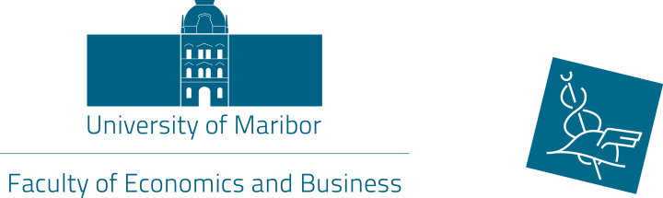

12th International week

Preliminary Programme
7 – 11 May, 2018
7 May, 2018 (Monday)
Faculty of Economics and Business
2nd International Scientific Conference »Teaching Methods for Economics and Business Sciences«
8.30 – 9.00 Registration
9.00 – 9.30 Conference opening addresses
10.00 – 16.30 Paper presentations (*with lunch break)
19.00 *Networking dinner

8 May, 2018 (Tuesday)
Faculty of Economics and Business
Lectures (TSM), presentations (ST) and workshops by participants
(Location and schedule will be sent later)
Social programme:
16.00 *City guided tour
17.30 *Vinag wine cellar tour and wine tasting
9 May, 2018 (Wednesday)
Faculty of Economics and Business
Lectures (TSM), presentations (ST) and workshops by participants
(Location and schedule will be sent later)
*Lunch, dinner and social programme are organized by FEB they are free of charge of International week particiipants.
10 May, 2018 (Thursday)
Faculty of Economics and Business
Lectures (TSM), presentations (ST) and workshops by participants
(Location and schedule will be sent later)

11 May, 2018 (Friday)
Faculty of Economics and Business
Lectures (TSM), presentations (ST) and workshops by participants
(Location and schedule will be sent later)

