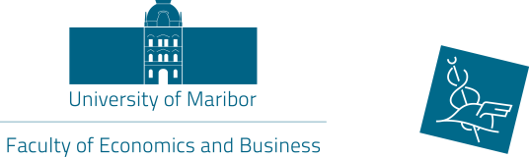
Application form

International week

organized by
the Faculty of Economics and Business

7 –11 May, 2018

1. Personal data:
Full Name
(first name/family name)
Department
Area
Position
Contact details (e-mail address and phone number)
Spoken language(s)
2. Home University:
Official Name
(in English)
Address

ERASMUS Code
Name & contact details of Erasmus Coordinator

3. Topic(s) of the lectures (TSM) or presentations (ST):
(Please state min. three topics which you would like to lecture during the International week):

Level of English:
4. Date of arrival and departure:
Arrival:

Departure:

5. International Conference ‘Teaching Methods for Economics and Business Studies’
Would you also like to participate at the Conference?  If yes, please send us also the registration form for the Symposium! | YES NO

6. Accommodation recommendations:
We have already pre-booked rooms for the participants at very reasonably prices at the hotels stated below!  Please choose one option: | Please, make the hotel reservation (email) by yourself!
Hotel Bajt  Link: http://www.hotel-bajt.com/en/  39eur/night including breakfast for single room | YES NO
Hotel Tabor  Link: http://www.hoteltabor-maribor.si/en/  42,50/night including breakfast for single room  59,50/night including breakfast for double room | YES NO
Hotel Orel – city center  Link: http://www.hotel-orel.si/en/  63,75/night including breakfast for single room  93,50/night including breakfast for double room | YES NO

Date:
Signature of Applicant

Date:
Signature and stamp of Erasmus Coordinator of Home University

Please return your application form by e-mail to
sanja.kocijan@um.si or polonca.mlakar@um.si or
by fax to +386 2 22 90 217
until Tuesday, 10 April 2018!

