
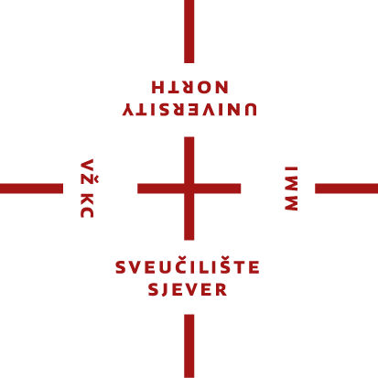
Erasmus+ student mobility for studies between programme countries (KA131) – ac. year 2024/2025 and 2025/2026
PRELIMINARY APPROVAL FOR FINAL THESIS

This is a preliminary approval document to insure the final thesis activity can be carried out and mentored at the receiving institution within Erasmus+ framework student mobility for studies. Used only for the purposes of student application to the University North Call for Erasmus+ SMS (studies) for ac. years 2024/2025 and 2025/2026.

Student name:
Subject/field of the final thesis:
Name of receiving organisation (HEI):
Erasmus code:
Country:
Student’s mentor (name): | if applicable at this stage – see footnote
E-mail:
Phone:
Signature (mentor):
Signature person in charge (University international relations office; signature of either the mentor or IRO office is mandatory).
Stamp (institution) - mandatory:

Name of sending organisation (HEI): | University North
Erasmus code: | HR VARAZDI02
Name of department:
Student's mentor (name):
E-mail:
Signature (mentor):

Herewith, the receiving University approves to supervise and mentor the above mentioned student of the University North, in the period from __/_____ (month, year) until __/_____ (month, year), for the purpose of writing the final thesis/research for the final thesis within the framework of Erasmus+ student for studies activity in the academic year 202_/202_.

- Receiving institution mentor: if the institution's procedure allows later defining of the mentor, please fill in „to be defined“

