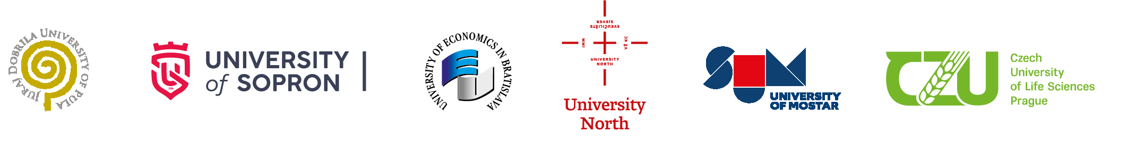
On behalf of all partner institutions,
Consortium of International Joint Cross Border PhD Programme in International Economic Relations and Management
cordially invites you to a final defense of the doctoral thesis of the
PhD applicant
. Boris JURIĆ

October 10, 2025, 2.00 pm
Venue:
Doctorate, Campus 2, Eisenstadt, Austria

The title of the PhD dissertation:
The Sustainability of Adriatic Islands Through the Lens of Macromarketing

Chair of the Reviewing Committee:
Prof. Dr. Sc. Dean Sinković, PhD MBA, University Juraj Dobrila in Pula, Croatia

Reviewers of the dissertation:
Prof. Dr. Sc. Zdenko Klepić, University of Mostar, Mostar, BiH
Prof. Dr. Sc. Goran Kozina, University North, Varaždin, Croatia

Members of the Scientific Committee:
Prof. Dr. Sc. Sanja Bijakšić, University of Mostar, BiH
Prof. Dr. Arnela Bevanda, PhD, University of Mostar, BiH

Supervisors of the applicant:
Prof. Dr. Sc. Anica Hunjet, PhD, University North, Varaždin, Croatia
Prof. Dr. Sc. Senad Bećirović, University of Economics in Bratislava, SK

