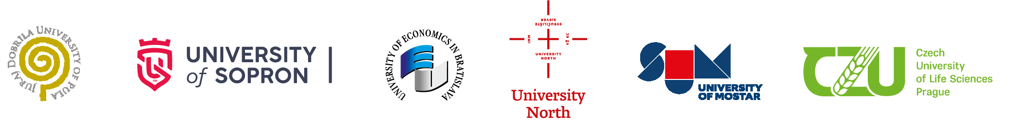
On behalf of all partner institutions, Consortium of
International Joint Cross Border PhD Programme in International Economic Relations and Management

cordially invites you to a defence of the doctoral thesis of the
PhD applicant

Marko MALENICA
Date of the defence:
Mai 7, 2025, at 3.30 pm.

Venue:
University North, Varaždin, Croatia

The title of the PhD dissertation:

SYNERGY OF NETWORKED INNOVATIONS ACROSS
THE EUROPEAN UNION

Chair of the Reviewing Committee:
Dr. habil. Prof. Eva Jančikova, University of Economics in Bratislava, SK

Reviewers of the dissertation:
Prof. Ing. Dr. Martin Grešš, University of Economics in Bratislava, SK
Prof. Dr. Sc. Valter Boljunčić, University Juraj Dobrila in Pula, Croatia

Members of the scientific committee:
Prof. Dr. Sc. Anica Hunjet, PhD, University North, Varaždin, Croatia
Prof. Arnela Bevanda, PhD, University of Mostar, BiH

Supervisor of the doctoral student:

Prof. Dr. Sc. Ante Rončević, University North, Varaždin, Croatia

